Nuventive Improvement User Guide

For Core Curriculum Courses

Section 1: Accessing Nuventive Improvement 4

Logging In 4

User Access 4

Section 2: New Features 5

Customized Home Page 5

Right-Side Panel 5

Section 3: Selecting Desired Course 7

Section 4: Home 8

Report Status 8

Results Details 9

MAP Scores 10

Right-Side Panel Documents 11

Section 5: Course Information 12

Course Information 12

Personnel 13

Section 6: Course Assessment 14

Plan & Results 14

Outcomes 14

Assessment Method 16

Results & Analysis 17

Results 18

Use of Results 19

Follow-Up 20

Right-Side Panel Documents 21

Review and Feedback 21

Right-Side Panel Documents 22

Section 7: Reports 23

Right-Side Panel Documents 23

Section 8: Document Library 24

**System Overview**

Nuventive Improvement Premiere Platform is an assessment and planning system developed to collect and share assessment data. It is designed to overcome common obstacles and close the loop between planning and action. The system facilitates assessment plans and results in data collection, review, and management. It provides formatted reports that address critical aspects of the assessment cycle.

# Section 1: Accessing Nuventive Improvement

## Logging In

There are two ways to access Nuventive Improvement:

1. Visit: [http://solutions.nuventive.com](http://solutions.nuventive.com/).

* The screen below will appear. Click on “Sign in” on the top right of the page. Enter your AD Username and Password (the Username is your email without @fiu.edu).

1. Visit [tracdat.fiu.edu](tracdat.fiu.edu/). This is the Institutional Effectiveness team’s Assessment Hub.
   * Scroll down and click on Submit Data to navigate to the Nuventive Improvement platform.

## User Access

* **Returning users:** Enter your AD Username and Password (the Username is your email without @fiu.edu).
* **Add and/or remove users:** <https://airtable.com/app3SmT0yoAqjDoz2/shr3FgpkxWEIzNJfe>

# Section 2: New Features

## Customized Home Page

The newly customized Home Page provides completion data for the assessment report selected, per outcome, per required field, and per reporting period. This makes it easier to identify which required components for a particular reporting period are missing to be entered. It also provides trend analyses on scores received from the Metric of Assessment Performance (MAP), the Institutional Effectiveness’ tool to evaluate assessment reports. Refer to Section 4 for further details on the Home Page.

## Right-Side Panel

The right-side panel provides relevant resources and reports (e.g., links to generating assessment reports) for each section of the system.

To access this panel, use any of the four icons on the right side of the page, which allow for size customization.

Each section of this guide will discuss any relevant documents within the right-side panel, if applicable.

# Section 3: Selecting Desired Course

After logging in, a drop-down box will appear at the top center of the screen. Use this box to select the appropriate course and modality.

Once the course is selected, the hamburger icon on the top, left side of the page, is used to navigate through the components of the course assessment report.

# Section 4: Home

The Home screen contains three tabs: Report Status, Results Details, and MAP Scores.

## Report Status

The Report Status tab displays information on submitted, pending, and/or not required fields per reporting period for the overall assessment report. The table provided breaks down the fields (i.e., components) of an assessment report (e.g., Results, Use of Results, etc.) and indicates when each are due for each reporting period. **This table is used to determine whether all required fields of the overall assessment report have been submitted for a reporting period.**

To identify which fields of the overall assessment report are complete, pending, and/or not required for a reporting period, refer to the legend provided.

To view a single reporting period, use the filters at the top of the page.

If a field for a reporting period is marked as incomplete (i.e., shows the red circle), use the next tab, Results Details, to identify exactly which outcome(s) are missing to have this field completed. If there are green circles across all fields, or the “Not Required” yellow dash, for a reporting period, then all required fields have been submitted.

**NOTE:** The green circles only indicate required fields have been submitted. The quality of the data submitted will still be reviewed by the Institutional Effectiveness team and the program/department/unit may be contacted to address feedback.

## Results Details

The Results Details tab displays information on submitted, pending, and/or not required fields per reporting period AND per outcome of the assessment report (i.e., it indicates which fields are submitted, pending, and/or not required for *each* outcome within the report). **This table is used to determine which field(s) of a particular outcome are missing.**

Use the Reporting Period filter to look at a single reporting period.

## MAP Scores

The Metric of Assessment Performance (MAP) is the tool/rubric the Institutional Effectiveness team utilizes to evaluate assessment reports. This tab provides scores earned per component of the MAP, including a visual trend analysis, and access to the feedback provided by the reviewer.

## Right-Side Panel Documents

The right-side panel of the Home screen contains links to four documents:

1. *Course Assessment Plan:* Assessment Plan for the course (outcomes and methods only). This report does NOT contain results. Filter for Outcome Status is available.
2. *Course Assessment Report*: Complete assessment report for the course (outcomes, methods, results, improvement actions, etc.). Filters for Outcome Status and Reporting Period are available.
3. *MAP Rubric*: Metric of Assessment Performance (MAP) tool used by the Institutional Effectiveness team to evaluate University Core Curriculum course assessment reports.
4. *MAP Score Report*: Metric of Assessment Performance (MAP) tool with ratings and feedback from the Institutional Effectiveness team. Filter by Review Year is available.

# Section 5: Course Information

To view Course Information, click on the hamburger menu icon at the top left of the page.

The Course Information section is comprised of two sub tabs: Course Information and Personnel.

## Course Information

The Course Information sub tab will display the UCC category, category description, designation(s), and department affiliation.

This is a read-only section. If changes are needed, please email us at [assess@fiu.edu](mailto:assess@fiu.edu).

## Personnel

The Personnel sub tab will display all individuals who have access to the report, along with their corresponding role. This is a read-only section. Follow the instructions above the table to request new user access and/or to remove a current user.

# Section 6: Course Assessment

To view Course Assessment, click on the hamburger menu icon at the top left of the page. **This is the section used to enter data.**

The Course Assessment section is comprised of two sub sections: Plan & Results and Review and Feedback.

## Plan & Results

**This is the section used to enter data.**

### Outcomes

This area displays the **outcomes** for the course (both active and archived) in a “card” format, with one outcome displayed per card.

Each card is used to navigate to the Assessment Method and Analysis & Results components of the outcome. To add/remove/edit outcomes, follow the instructions on the yellow informational box at the top, or email us at [assess@fiu.edu](mailto:assess@fiu.edu) for assistance.

To change which outcomes are shown (e.g., to only see active outcomes), use the filter at the top.

To view additional outcome details (e.g., start/end dates, alignments, etc.), double-click on the outcome’s card.

This is a read-only section. To make changes, follow the instructions in the yellow informational box or email us at [assess@fiu.edu](mailto:assess@fiu.edu).

After double-clicking on the outcome card, the navigation to the Assessment Method and Results & Analysis sections will appear.

### Assessment Method

The Assessment Method area displays the components of the assessment method established for the outcome (e.g., sampling strategy, minimum criteria for success, etc.).

This is a read-only section. To make changes, follow the instructions in the yellow informational box or email us at [assess@fiu.edu](mailto:assess@fiu.edu) for assistance.

## Results & Analysis

The Results & Analysis area is where data per reporting period can be found and where additional data are entered. The outcome is displayed at the top, and filters for Method Status and Reporting Period are available.

**To edit existing data**, click on the three vertical dots on the right side of the page.

**To enter data for a new reporting period**, click on the plus sign on the right.

### Results

When adding new results, the below fields will generate. All required fields are marked with an asterisk. The light green box at the top can be used to ensure data are being provided for the correct method. **Results for all core courses are due annually.**

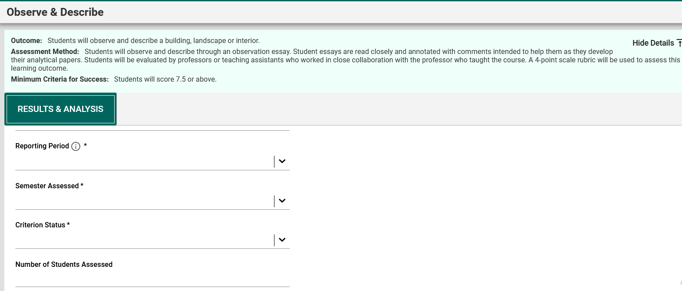

* *Results Date*: Date when Results were entered. Field populates automatically.
* *Reporting Period*: Academic year of when data were collected.
* *Semester Assessed*: Semester(s) in which data were collected.
* *Criterion Status*: Percentage range by which outcome was met, based on minimum criteria for success established.
* *Number of Students Assessed*: Number of students in the sample size*.*
* *Number of Students Who Met the Minimum Criteria for Success*: Number of students, from those sampled, that met the established minimum criteria.
* *Results*: Data based on established method
* *Analysis*: Insights on data collected (e.g., trend analysis across multiple years).
* *Results Documents*: Documents to support the results provided (e.g., completed rubrics).
* *Tables & Charts*: Images, tables, etc., that display, or further support, results provided.

**QUICK TIP:** Use the light green box at the top to ensure data are being entered for the correct outcome and method and to look at the previously-established minimum criteria for success.

### Use of Results

Underneath the Results area will be Use of Results. These are the improvement action(s) that will be implemented (i.e., the plan) the following year. **Use of Results are due at the end of the two-year cycle (i.e., the second year of the cycle).** **If data are being entered for the first year of the cycle, please leave Use of Results blank.**

Once Results and Use of Results (if applicable) are entered, click on Save at the top right.

**QUICK TIP:** To switch outcomes (i.e., to enter data for a different outcome), click on the drop-down menu on the right.

### Follow-Up

Underneath the Results section will be Follow-Ups. Follow-Ups is the “closing the loop” section where it is discussed whether Use of Results submitted at the end of the two-year cycle were implemented and evidence of implementation are provided.

**NOTE: As Follow-Ups are provided one year *after* the Use of Results are submitted, use the Results card of the previous reporting period to submit Follow-Ups (i.e., Edit the card of the previous reporting period by clicking on the three vertical dots and scroll down to complete the Follow-Up section). This means that:**

* **1st year of the cycle: A new Results entry is created AND the previous year’s card is edited to enter Follow-up and evidence**
* **2nd year of the cycle: A new Results entry is created that includes Results AND Use of Results**

## Right-Side Panel Documents

The right-side panel of the Plans & Results section contains links to three documents:

1. *Assessment Template*: Use this template to change outcomes and/or methods.
2. *Assessment Plan*: Report showing all outcomes and methods for the course. Filter for Outcome Status is available.
3. *Assessment Report*: Report showing the complete assessment report for the course (outcomes, methods, results, etc.,). Filters for Outcome Status and Reporting Period are available.

## Review and Feedback

This section displays scores obtained on the Metric of Assessment Performance (MAP) as well as feedback provided by the Institutional Effectiveness (IE) team on the assessment report, per reporting period. To view the report with the feedback provided, click on the three vertical dots on the right.

## Right-Side Panel Documents

The right-side panel of the Review and Feedback section contains links to two documents:

1. *MAP Rubric*: Blank Metric of Assessment Performance rubric
2. *MAP Score report*: Report containing scores and feedback from the IE team. Filter is available for Review Year.

# Section 7: Reports

The Reports section allows the creation of reports for the course.

The document displayed explains the types of reports available to generate.

## Right-Side Panel Documents

The right-side panel of the Review and Feedback section contains links to two documents:

1. *SLO Assessment Plan*: Report showing all outcomes and methods for the course. Filter for Outcome Status is available.
2. *SLO Assessment Report*: Report showing the complete assessment report for the course (outcomes, methods, results, etc.,). Filters for Outcome Status and Reporting Period are available.

# Section 8: Document Library

The Document Library section houses all documents uploaded onto the report (e.g., evidence documents).

Folders can be created to maintain files organized.

